Slovak University of Agriculture in Nitra

Creation of Assets Portfolio in Financial Markets:

Optimal Portfolio,Profitability and Risk of Portfolio

Suzana Bulatovič

2nd class
FEM
MPA
Abstract

Financial portfolio represents a certain type of investments diversification and hence it issues a possibility how to reduce risk ratio and to ensure a sufficient profitability of financial investment.
The paper shows ways of calculation and evaluation of investment possibilities. A base for the determination of the efficiency of portfolio particular parts is a rate of efficiency of particular securities and their weight (representation) in the portfolio. Risk of an investment action is linked to the results of the technical analysis of particular securities and of the mutual dependence among them, resp. of their mutual ability to influence each other. The contribution is worked out on a theoretical basis, nevertheless, the procedure can be applied easily to the investment possibility in the area of securities. It cannot be used in enterprises of agricultural primary production but it can be applied in the dimension of the agri-food complex, respectively in the agri-business dimension.

Keywords
financial investment,portfolio,profitability,risk radio

Introduction

Every investment and especially a financial investment is influenced by many factors.Among the most imortrant of them, there belong the following three factors:profitability,risk ratio and time.An investor has to consider these three facors very carefully before he realize the investment.An ideal situation would be if the investment brings a high return without any risk.However, because this situation is illusory, investment possibilities should be chosen considering an “ acceptability” of profitability and a” risk capacity”.A basic and generally known rule is valid-do not focus only on one investment possibility,i.e. one security, but a final investment should represent the so called financial portfolio,i.e.it should be composed by more securities.A financial portfolio is a certain type of investment diversification.It is a possibility to reduce the risk ratio and secure sufficient profitability.

Market portfolio
A market portfolio is a theoretical portfolio in which every available type of asset is included at a level proportional to its market value. Described as a group of investments, a portfolio is owned by one individual or organization. The typical investment portfolio may include a variety of assets, but usually does not include all asset types. However, a market portfolio literally includes every asset that exists in the market.
The market value of an investment is described as its current price on the market. The term is also used to refer to the amount for which an asset could presumably be resold. In a market portfolio, investments are held in proportion to their market values in relation to the full value of all included assets.
Often, the concept of a market portfolio is discussed in theoretical terms only. For investment purposes, a true market portfolio would need to include every conceivable asset. As such, the market for such a portfolio would be the world market. The market portfolio concept is important in a variety of financial theories, including Modern Portfolio Theory (MPT). According to the MPT, investors should concentrate on choosing portfolios based on overall risk-reward concepts, rather than focusing on the attractiveness of individual securities.
MPT involves the concept of the efficient frontier on which the market portfolio sits. Introduced by Harry Markowitz, the pioneer of MPT, the efficient frontier is a group of optimal portfolios that serve to maximize expected return for a given level of risk. The Sharpe ratio is a term used to indicate the level of additional return offered by a portfolio, relative to the level of risk it entails. The market portfolio, also called the super-efficient portfolio, has the highest Sharpe ratio on the efficient frontier.
When combined with the risk-free asset, it is said that the market portfolio will produce a return rate above the efficient frontier. The risk-free asset is a hypothetical concept. Essentially, the market portfolio would provide for higher return rates than a riskier portfolio on the frontier.

Portfolio optimalization
The optimal portfolio concept falls under the modern portfolio theory. The optimal portfolio was used in 1952 by Harry Markowitz, and it shows us that it is possible for different portfolios to have varying levels of risk and return. Each investor must decide how much risk they can handle and than allocate (or diversify) their portfolio according to this decision.

The chart below illustrates how the optimal portfolio works. The optimal-risk portfolio is usually determined to be somewhere in the middle of the curve because as you go higher up the curve, you take on proportionately more risk for a lower incremental return. On the other end, low risk/low return portfolios are pointless because you can achieve a similar return by investing in risk-free assets, like government securities.

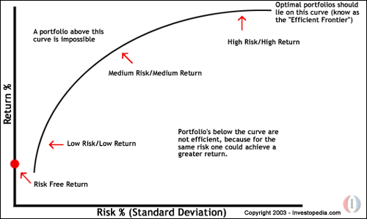

You can choose how much volatility you are willing to bear in your portfolio by picking any other point that falls on the efficient frontier. This will give you the maximum return for the amount of risk you wish to accept. Optimizing your portfolio is not something you can calculate in your head. There are computer programs that are dedicated to determining optimal portfolios by estimating hundreds (and sometimes thousands) of different expected returns for each given amount of risk.
Spreadsheet for Portfolio Optimization - Many Assets

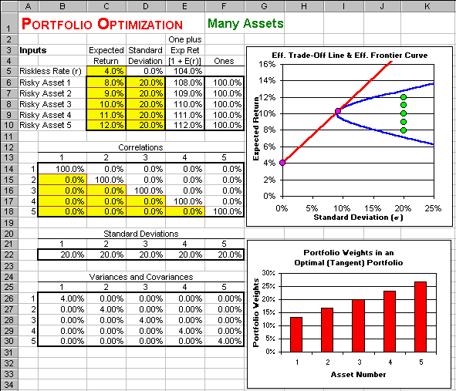

Modern portfolio theory

Modern portfolio theory (MPT) proposes how rational investors will use diversification to optimize their portfolios, and how a risky asset should be priced. The basic concepts of the theory are Markowitz diversification, the efficient frontier, capital asset pricing model, the alpha and beta coefficients, the Capital Market Line and the Securities Market Line.
MPT models an asset's return as a random variable, and models a portfolio as a weighted combination of assets; the return of a portfolio is thus the weighted combination of the assets' returns. Moreover, a portfolio's return is a random variable, and consequently has an expected value and a variance. Risk, in this model, is the standard deviation of the portfolio's return.

The efficient frontier

Every possible asset combination can be plotted in risk-return space, and the collection of all such possible portfolios defines a region in this space. The line along the upper edge of this region is known as the efficient frontier (sometimes "the Markowitz frontier"). Combinations along this line represent portfolios (explicitly excluding the risk-free alternative) for which there is lowest risk for a given level of return. Conversely, for a given amount of risk, the portfolio lying on the efficient frontier represents the combination offering the best possible return. Mathematically the Efficient Frontier is the intersection of the Set of Portfolios with Minimum Variance and the Set of Portfolios with Maximum Return.
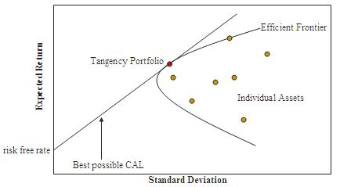
Efficient Frontier

The efficient frontier is illustrated above, with return μ_{p} on the y-axis, and risk σ_{p} on the x-axis; an alternative illustration from the diagram in the CAPM article is at right.
The efficient frontier will be convex – this is because the risk-return characteristics of a portfolio change in a non-linear fashion as its component weightings are changed. (As described above, portfolio risk is a function of the correlation of the component assets, and thus changes in a non-linear fashion as the weighting of component assets changes.) The efficient frontier is a parabola (hyperbola) when expected return is plotted against variance (standard deviation).
The region above the frontier is unachievable by holding risky assets alone. No portfolios can be constructed corresponding to the points in this region. Points below the frontier are suboptimal. A rational investor will hold a portfolio only on the frontier.

Portfolio return
Most investors do not hold stocks in isolation. Instead, they choose to hold a portfolio of several stocks. When this is the case, a portion of an individual stock's risk can be eliminated, i.e., diversified away. This principle is presented on the Diversification page. First, the computation of the expected return, variance, and standard deviation of a portfolio must be illustrated.
Once again, we will be using the probability distribution for the returns on stocks A and B.
State | Probability | Return on  Stock A | Return on  Stock B
1 | 20% | 5% | 50%
2 | 30% | 10% | 30%
3 | 30% | 15% | 10%
3 | 20% | 20% | -10%
From the Expected Return and Measures of Risk pages we know that the expected return on Stock A is 12.5%, the expected return on Stock B is 20%, the variance on Stock A is .00263, the variance on Stock B is .04200, the standard deviation on Stock S is 5.12%, and the standard deviation on Stock B is 20.49%.

Portfolio Expected Return
The Expected Return on a Portfolio is computed as the weighted average of the expected returns on the stocks which comprise the portfolio. The weights reflect the proportion of the portfolio invested in the stocks. This can be expressed as follows:
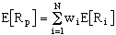
where
- E[R_{p}] = the expected return on the portfolio,
- N = the number of stocks in the portfolio,
- w_{i} = the proportion of the portfolio invested in stock i, and
- E[R_{i}] = the expected return on stock i.
For a portfolio consisting of two assets, the above equation can be expressed as
Expected Return on a Portfolio of Stocks A and B
Note: E[R_{A}] = 12.5% and E[R_{B}] = 20%
Portfolio consisting of 50% Stock A and 50% Stock B
Portfolio consisting of 75% Stock A and 25% Stock B

Portfolio Risk
For present purposes we will use as a measure of portfolio risk the standard deviation of the distribution of its one-period return or the square of this value, the variance of returns.
By definition, the variance of a portfolio's return is the expected value of the squared deviation of the actual return from the portfolio's expected return. It depends, in turn, on the possible asset returns (R), the probability distribution across states of the world (p) and the portfolio's composition (x). The relationship is, however, somewhat complex.
To begin it is useful to create a matrix of deviations of security returns from their expectations. This can be accomplished by subtracting from each security return the corresponding expectation:
d = R - e*ones(1,s)
The result (d) shows the deviation (surprise) associated with each security in each of the states of the world. Here:
Good Fair Poor Bad
Asset1 0.00 0.00 0.00 0.00
Asset2 2.90 0.90 -1.10 -12.10
Asset3 13.00 0.00 -10.00 -32.00

Standard Deviation
We can measure risk by using standard deviation. Higher standard deviation means higher risk.

Probability Distribution - In Business
Economic Outcome | Probability | Return on Investment
Great | 20% | 25%
Good | 40% | 15%
So-So | 30% | 5%
Really Bad | 10% | 0%

Economic Outcome | Return on Investment | minus | ERR - the Expected Rate of Return | equals | answer | squared | times | Probability of the Economic Outcome | equals | Answer
Great | 25% | - | 12.5% | = | 12.5 | 156.25 | X | 20% | = | 31.25
Good | 15% | - | 12.5% | = | 2.5 | 6.25 | X | 40% | = | 2.5
So-So | 5% | - | 12.5% | = | 7.5 | 56.25 | X | 30% | = | 16.875
Really Bad | 0% | - | 12.5% | = | 12.5 | 156.25 | X | 10% | = | 15.625
 |  |  |  |  |  |  |  | Total | = | 66.25
- So the total is 66.25. This is called the Variance.
- The square root of 66.25 = 8.139
- So the Standard Deviation is 8.139

Capital asset pricing model

The Capital Asset Pricing Model (CAPM) is used in finance to determine a theoretically appropriate required rate of return (and thus the price if expected cash flows can be estimated) of an asset, if that asset is to be added to an already well-diversified portfolio, given that asset's non-diversifiable risk. The CAPM formula takes into account the asset's sensitivity to non-diversifiable risk (also known as systematic risk or market risk), often represented by the quantity beta (β) in the financial industry, as well as the expected return of the market and the expected return of a theoretical risk-free asset.
The model was introduced by Jack Treynor, William Sharpe, John Lintner and Jan Mossin independently, building on the earlier work of Harry Markowitz on diversification and modern portfolio theory. Sharpe received the Nobel Memorial Prize in Economics (jointly with Markowitz and Merton Miller) for this contribution to the field of financial economics.
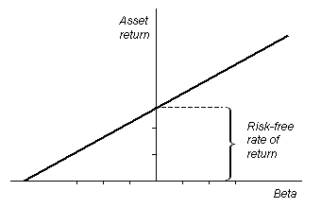
The CAPM is a model for pricing an individual security (asset) or a portfolio. For individual security perspective, we made use of the security market line (SML) and its relation to expected return and systematic risk (beta) to show how the market must price individual securities in relation to their security risk class. The SML enables us to calculate the reward-to-risk ratio for any security in relation to that of the overall market. Therefore, when the expected rate of return for any security is deflated by its beta coefficient, the reward-to-risk ratio for any individual security in the market is equal to the market reward-to-risk ratio, thus:
Individual security’s / beta = Market’s securities (portfolio)
Reward-to-risk ratio Reward-to-risk ratio
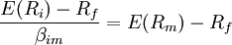,
The market reward-to-risk ratio is effectively the market risk premium and by rearranging the above equation and solving for E(Ri), we obtain the Capital Asset Pricing Model (CAPM).
Where:
- is the expected return on the capital asset
- is the risk-free rate of interest
- (the beta coefficient) the sensitivity of the asset returns to market returns, or also 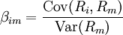,
- is the expected return of the market
- is sometimes known as the market premium or risk premium (the difference between the expected market rate of return and the risk-free rate of return). Note 1: the expected market rate of return is usually measured by looking at the arithmetic average of the historical returns on a market portfolio (i.e. S&P 500). Note 2: the risk free rate of return used for determining the risk premium is usually the arithmetic average of historical risk free rates of return and not the current risk free rate of return.

Conclusion

The main purpose of this study is possibilities of efficiency evaluation of investment into securities and the development of a model for evaluating the performance of portfolios of risky assets taking into account the effects of differential risk on required returns. The portfolio evaluation model developed here incorporates these risk aspects on the pricing of capital assets under uncertainty. Measure of portfolio performance is defined as the difference between the actual returns on a portfolio in any particular holding period and the expected returns on that portfolio conditional on the riskless rate, its level of systematic risk, and the actual returns on the market portfolio.

Resources

Capital asset pricing model.[online]. Retrieved at: 2008-04-10. Wikipedia - the free encyclopedia. Available at:
http://en.wikipedia.org/wiki/Capital_asset_pricing_model

Modern portfolio theory.[online]. Retrieved at: 2008-04-10. Wikipedia - the free encyclopedia. Available at: http://en.wikipedia.org/wiki/Modern_portfolio_theory

Portfolio.[online]. Retrieved at: 2008-04-09.Investopedia. Available at: http://www.investopedia.com/terms/p/portfolio.asp

What is a Market Portfolio? .[online]. Retrieved at: 2008-04-12.Wisegeek. Available at:
http://www.wisegeek.com/what-is-a-market-portfolio.htm

PORTFOLIO OPTIMIZATION - Many Assets.[online]. Retrieved at: 2008-04-07. Spreadsheetmodeling. Available at: http://www.spreadsheetmodeling.com/Portfolio%20Optimization%20-%20Many%20Assets.htm

Efficient Frontier.[online]. Retrieved at: 2008-04-09.Riskglossary. Available at: http://www.riskglossary.com/link/efficient_frontier.htm

Portfolio Expected Return.[online]. Retrieved at: 2008-04-05. Available at: http://www.stanford.edu/~wfsharpe/mia/rr/mia_rr4.htm

How to calculate the expected return on a portfolio.[online]. Retrieved at: 2008-04-13.
Available at: http://allfinancialmatters.com/2007/01/19/how-to-calculate-the-expected-return-on-a-portfolio/

Model: The CAP model (CAPM) .[online]. Retrieved at: 2008-04-13. .Encycogov. Available at: http://www.encycogov.com/A2MonitorSystems/AppA2MonitorSystems/AppBtoA2CAP_model/CAP_Model.asp

Useful internet sides

- www.411stocks.com (to find expected returns)
- www.investopedia.com (for more on risk measures)
- www.teachmefinance.com (also contains more on risk measure)
- www.morningstar.com (measure diversification using “instant x-ray”)
- www.datachimp.com (review modern portfolio theory)
- www.efficentfrontier.com (check out the online journal)
- www.finportfolio.com (portfolio analysis tools)

